**School of Mathematical & Computer**

**Sciences**



**Department of Computer Science**

**Course F20MC: Mobile Communication and Programming**

**“Coursework 2: Android Content Provider”**

**Beni Iyaka - H00181266**

*Bi34@hw.ac.uk*

**Professor: Talal Shaikh**

*December 3, 2015*

*Dubai*

Table of Contents

1.Introduction...................................................................................................................2

2. Summary of the technology used................................................................................3

3. Process followed ...........................................................................................................3

4.Application diagram…………………………….............................................................4

5.GUI screenshots…….....................................................................................................7

6. Source code ………………………………………………………………………………….10

6.Bibiliograpy.. ................................................................................................................13

**Introduction**

**Content providers** are one of the primary building blocks of Android applications, providing **content** to applications. They encapsulate data and provide it to applications through the single ContentResolver interface. (Johnson 2012)

Android devices come in all kinds of sizes, with all sorts of features, and at all sorts of prices. Each version of Android is named after a dessert. With Android, you’re in control of your mobile experience. (Android)

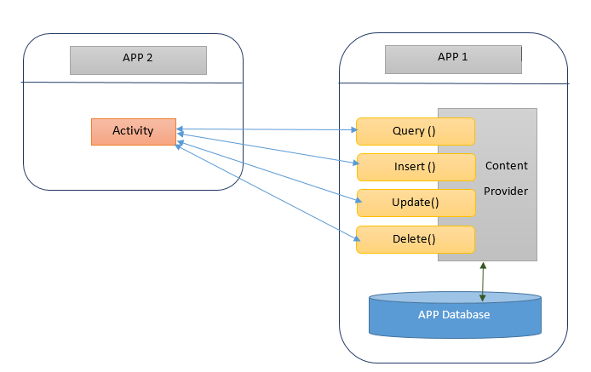

Figure 1 (Android)

The product I have created is a content provider application that stores countries details; and these details can also be accessed by other applications on the android phone that are linked to it.

The country details being:

* Continent
* Country code
* Capital city
* Population density
* Surface area
* Official language
* Number of provinces.

**Summary of technology used:**

The technology used in terms of programming the application was the following:

* Java: this was used to create class and some programming style.

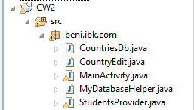

* XML: this was used to set up the style of which I want my application to have.

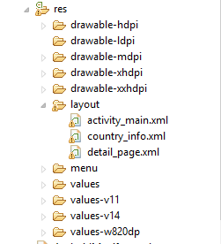

* Eclipse: this is the programming application I used to program the content provider application.

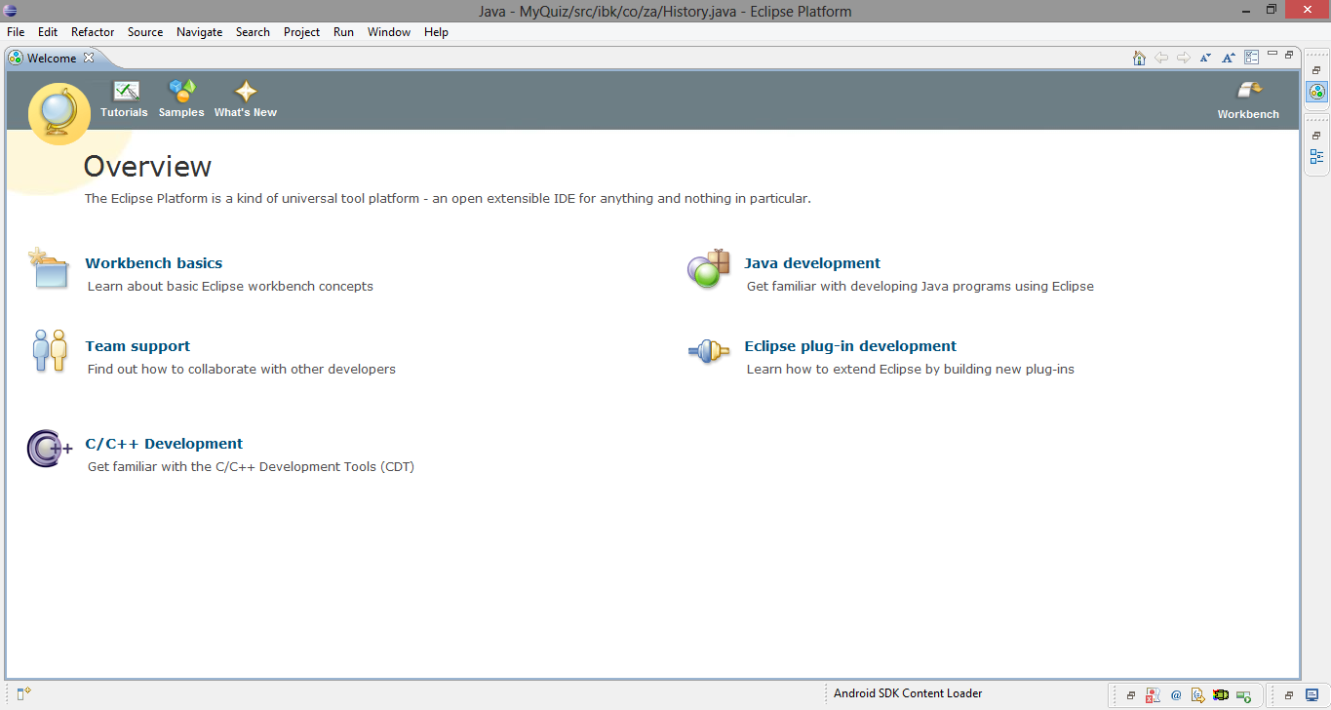

**Application diagram**



**GUI screenshots**

This is the first form of the application, it permits you either add a new country or edit a country that is already in the database.

To add a new country, the user needs to click on “Add new Country and they will be a second form where they can input different details of the country they want to add.

After filling in details, the user then clicks on saves and the country will be saved and displayed in the first form.

Practically:

1. 2.

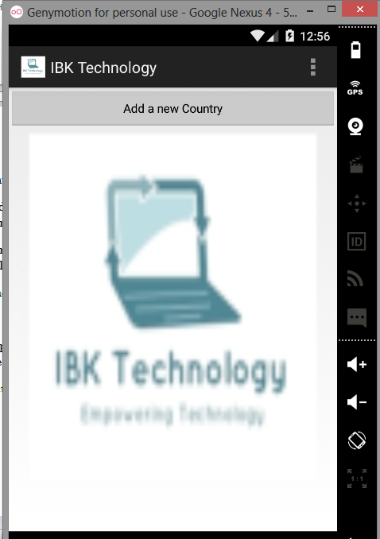 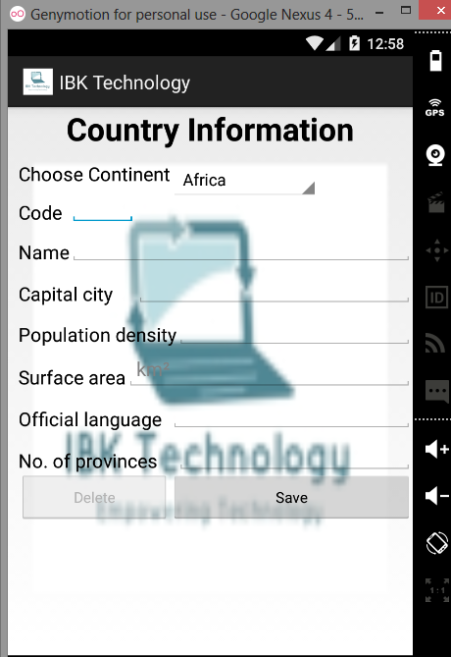

4. 3.

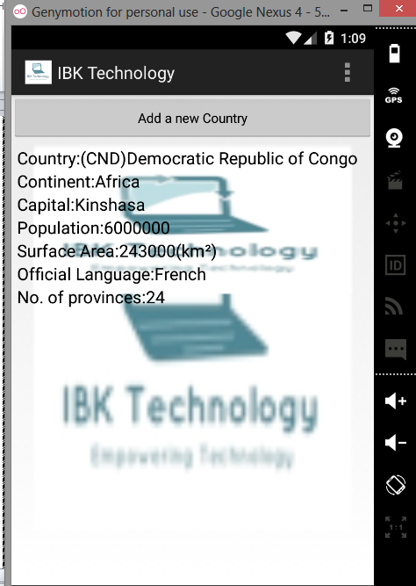 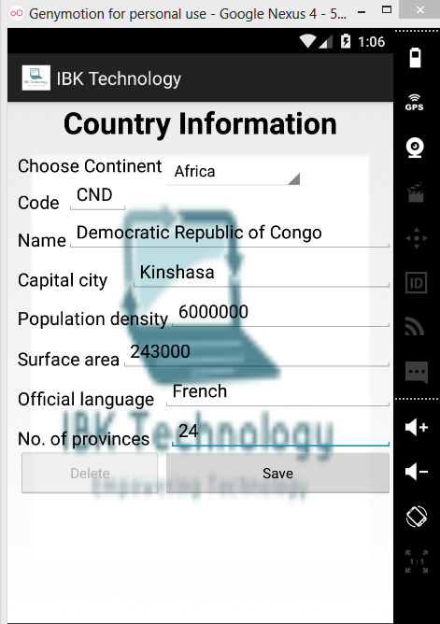

To update a certaing country, the user select the intended country and the second form will appear with details allowing the user to pick which field they want to update.

Practically:

1. 2.

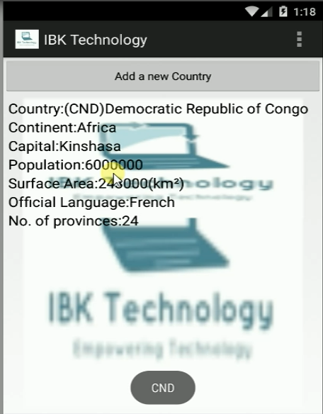 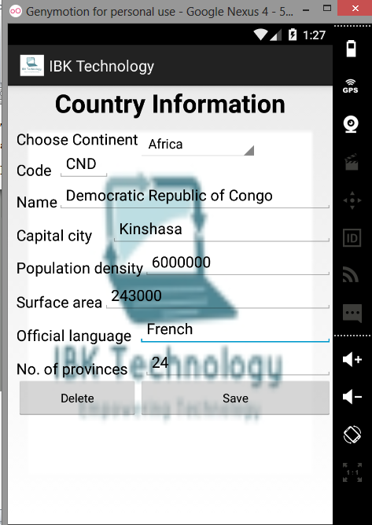

4. 3.

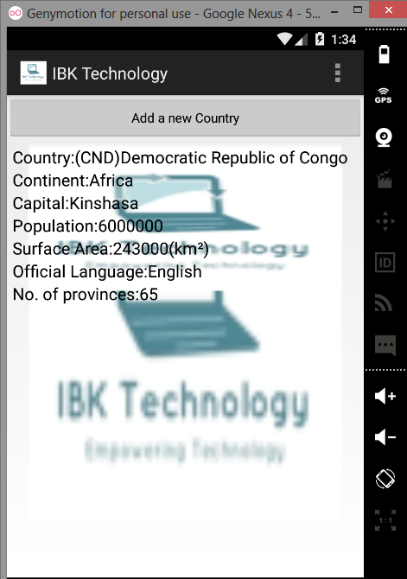 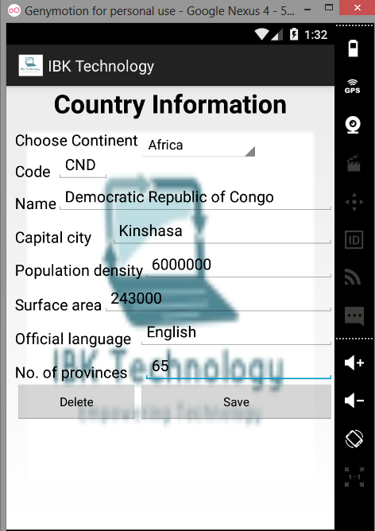

To delete a certaing country, the user select the intended country and the second form will with the delete button enabled and after selecting the delete button, the selected country will be deleted from the database.

Practically:

1. 2.

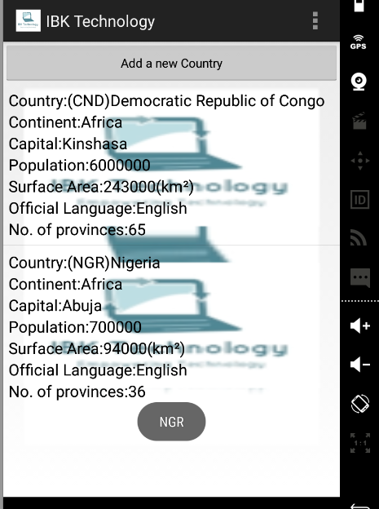 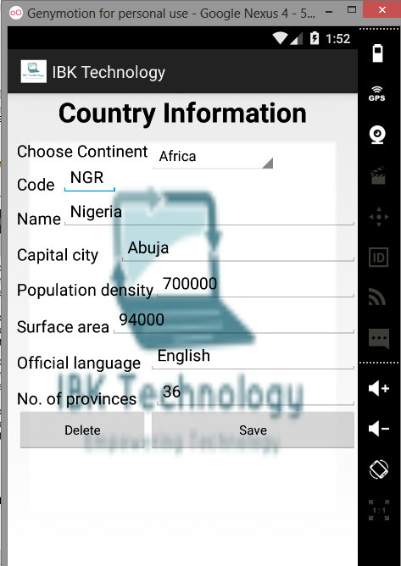

4..

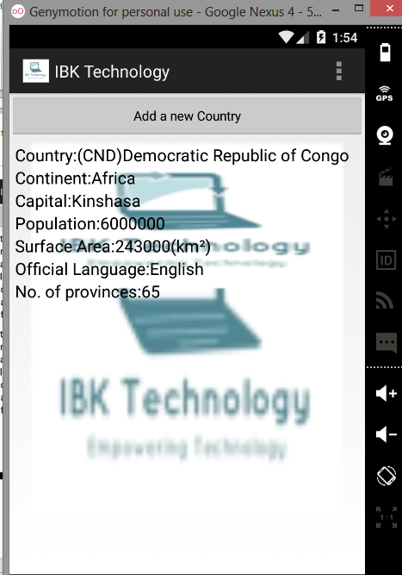

For this content provider, I made a second application that will read the details that was input in the main application.

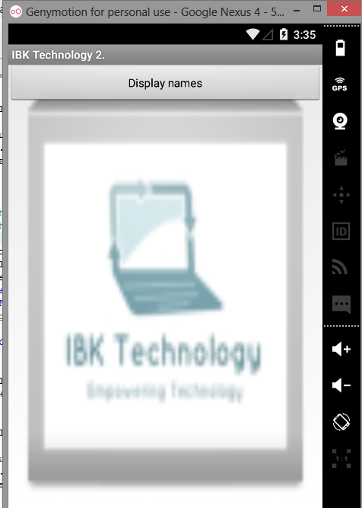 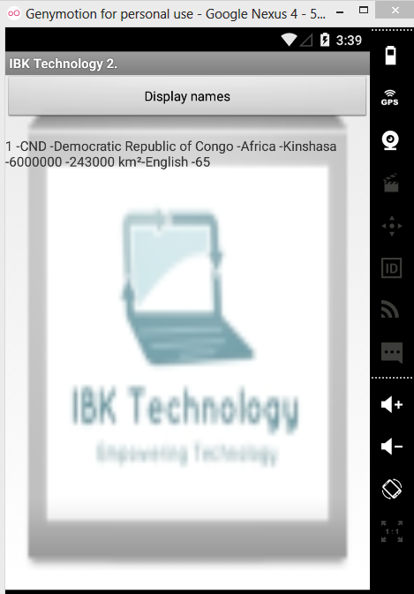

Content Provider

Specifying the content provider

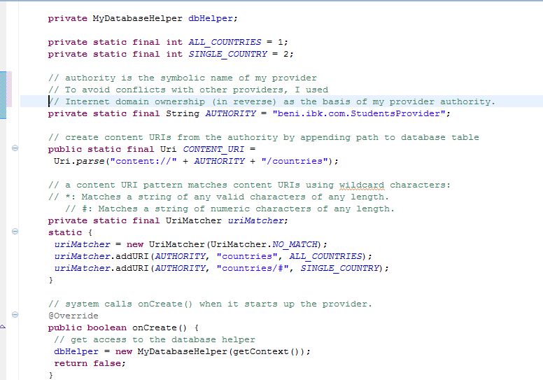

Return the MIME type to a content URI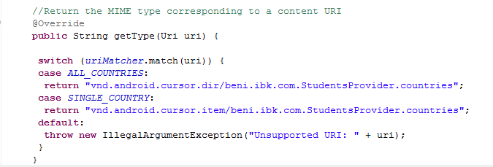

Inserting in the provider

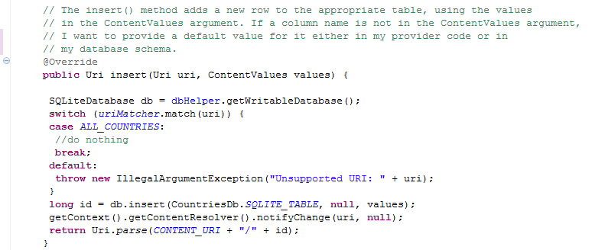

Checking the query

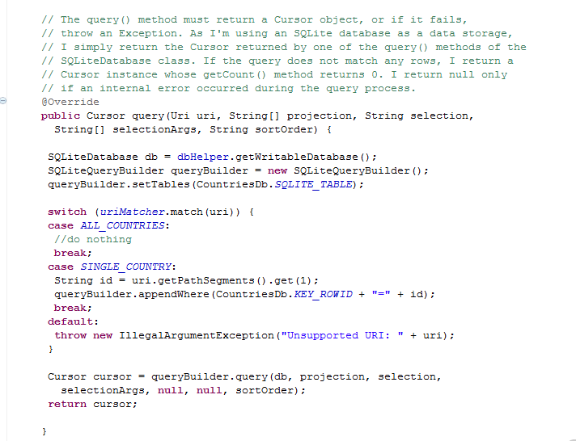

Deleting data in the provider

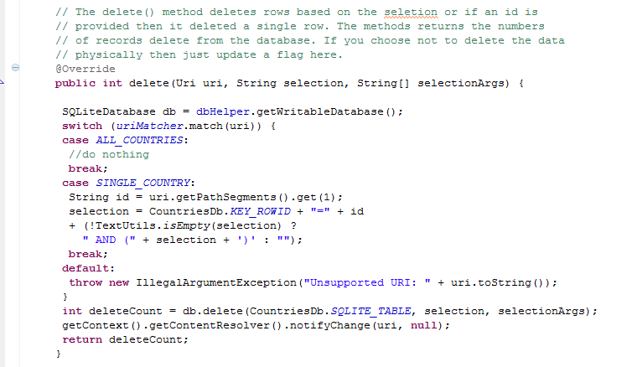

Updating data in the provider

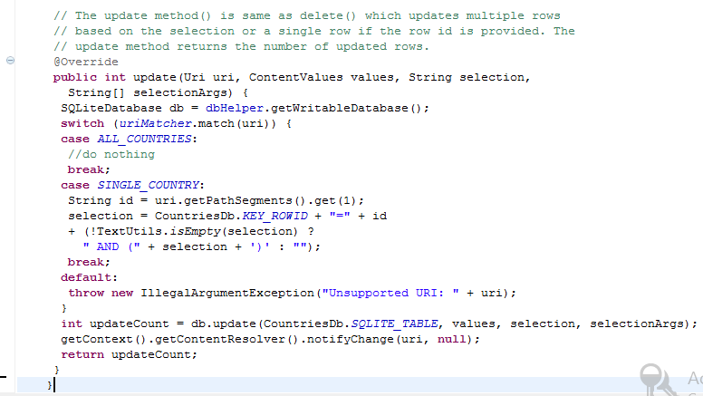

# Bibliography

*Android*. (n.d.). Retrieved 10 24, 2014, from Android: http://www.android.com

Bolton, M. (2011, 07 06). *What is android?* Retrieved 10 24, 2014, from Techractar: http://www.techractar.com